WEB assignment 4

Team name: OralBasar

Orazbek Ulan, Zhetpysbaev Adilbek

Group: SE-2406

Topic: Cinema

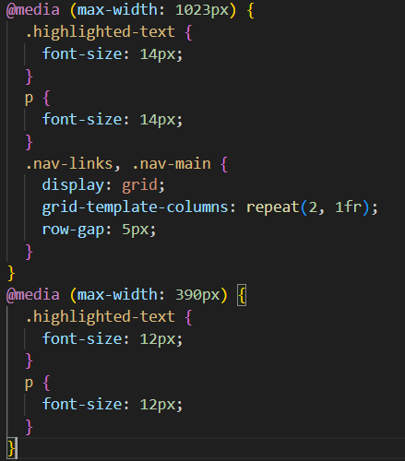

I implemented responsive typography using CSS media queries to adjust font sizes across different screen sizes. The code includes breakpoints at 1023px for desktop/tablet boundary and 390px for tablet/mobile boundary, with font sizes ranging from 12-14px for paragraphs and highlighted text depending on the viewport width, while navigation elements use CSS Grid with a two-column layout that adapts to smaller screens.

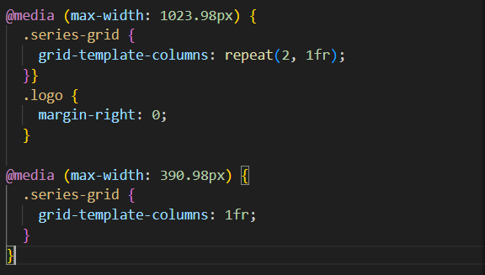

I created a responsive card layout using CSS Grid with media queries to control the column arrangement across different devices. The series-grid container uses repeat(2, 1fr) for desktop view showing all cards side by side, switches to a two-column layout at tablet breakpoint (1023.98px), and collapses to a single-column layout (1fr) on mobile devices (390.98px), while the logo styling was adjusted to remove right margins for better mobile presentation.

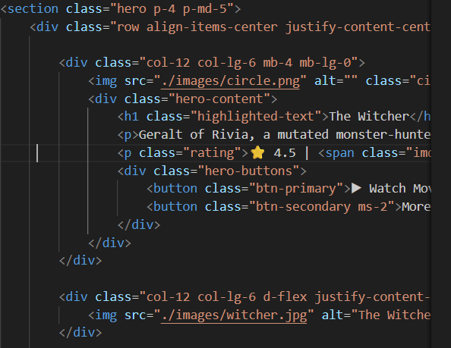

I implemented a responsive layout using Bootstrap's grid system with proper column classes for different screen sizes. The hero section uses Bootstrap's container with row and column classes (col-12 col-lg-6) to create responsive two-column layouts on large screens that stack vertically on mobile, featuring movie cards with images, titles, ratings, and action buttons with appropriate spacing classes like mb-4, mb-lg-0, and p-4 for consistent padding across devices.

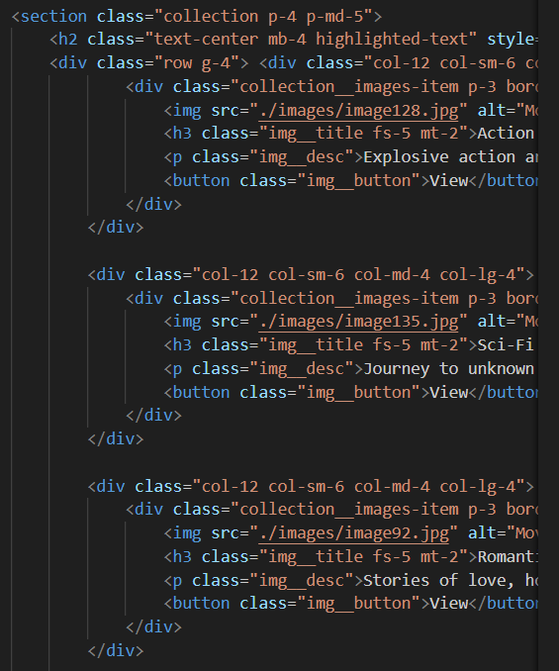

I refactored all custom spacing to use Bootstrap's utility classes throughout the collection section, applying classes like p-4 and p-md-5 for section padding, g-4 for grid gap, mb-4 for heading margins, and mt-2 for element spacing. The code demonstrates responsive spacing with col-12 col-sm-6 col-md-4 col-lg-4 classes for three-column layout on large screens, combined with consistent padding utilities (p-3) on collection items and margins (mt-2, fs-5) on titles and descriptions.

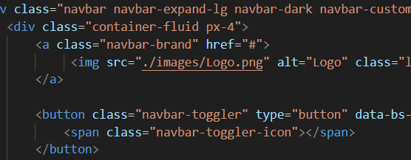

I created a fully responsive Bootstrap navigation bar using navbar-expand-lg and navbar-dark classes with a custom dark background. The navbar includes a logo brand link, a navbar-toggler button with hamburger icon for mobile devices, and is wrapped in a container-fluid with px-4 padding to ensure proper spacing and responsive collapse functionality on smaller screens.

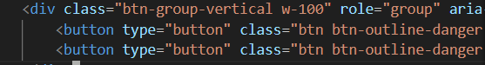

I replaced all custom button styles with Bootstrap button classes and implemented a vertical button group using btn-group-vertical with w-100 for full width. The buttons use Bootstrap's btn btn-outline-danger classes for consistent styling, and the group is structured with proper role and aria-label attributes for accessibility and responsive behavior across different screen sizes.

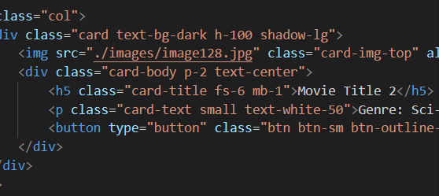

I implemented a Bootstrap carousel displaying movie cards with images, integrated into the grid system using col class for proper alignment. The carousel includes Bootstrap's card components with card, card-img-top, card-body, and card-title classes, styled with text-bg-dark, h-100, and shadow-lg, along with buttons using btn btn-sm btn-outline-light classes for consistent styling and responsive behavior.